A1105-Paleo-*Homo erectus pekinensis* female cranium and mandible, 780,000 BP



Fig. 1. *Homo erectus pekinensis* female cranium and mandible, reconstruction from Zhoukoudian casts of a calotte (skull cap) and two fragments of a maxilla and mandible by Franz Weidenreich, pre-1938. Illus. from Tattersall, Delson, and Couvering 2000:738.

Fig. 2. *Homo erectus pekinensis* male cranium and mandible, reconstruction from newly discovered Zhoukoudian fossil fragments by Tattersall and Sawyer (1996). Illus. from Tattersall, Delson, and Couvering 2000:738.

**Formal Label:** *Homo erectus pekinensis* female cranium and mandible, reconstruction by Franz Weidenreich, from ca 1938 casts.

**Display Description:** The forty*Homo erectus pekinensis* individuals (known collectively as “Peking, i.e. Beijing, Man”) that have been discovered at Zhoukoudian cave Locality 1, 42 km sw of Beijing, China, dating to 780,000 BP(Shen, Gao, Gao, and Granger 2009; Klein 2009), provide the earliest evidence for hominin occupation in Eastern Asia.

**Accession Number:**

**LC Classification:** GN282.H65

**Date or Time Horizon:** 780,000 BP

**Geographical Area:** Zhoukoudian, 42 km sw of Beijing, China.

**Map, GPS coordinates:** N39.689926. E115.93196; Lat.:39°41'0"N Long.: 115°56'5"E

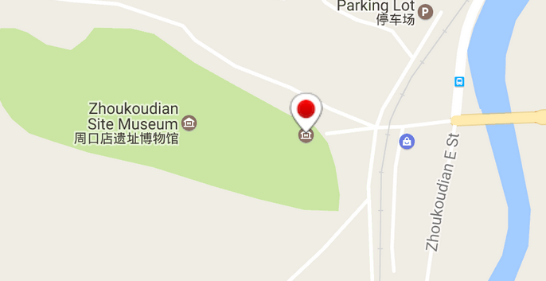 

Figs. 2-3. Maps of location of Zhoukoudian cave from <http://www.world-heritage-site.com/unesco-world-heritage/peking-man-site-at-zhoukoudian-map/>

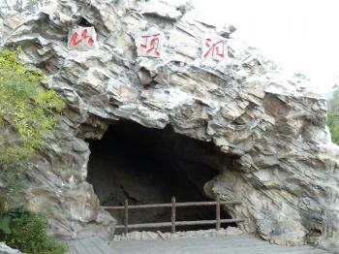

Fig. 4. Entrance to Zhoukoudian cave, from http://www.worldheritagesite.org/profiles/fotoos/10988.jpg.

**Cultural Affiliation:** *Homo erectus pekinensis*

**Medium:** *Homo erectus pekinensis* female cranium and mandible reconstruction from resin casts by Franz Weidenreich, ca 1938.

**Dimensions: H** 8 in.

**Weight: n/a.**

**Condition: museum resin replica**.

**Provenance:** resin reconstruction based on Franz Weidenreich’s casts.

**Discussion:** *Homo erectus* fossilswere discovered in 1891 in Java (“Java man”) by French anatomist Eugene Dubois and were classified as *Pithecanthropus erectus*. Then, in the 1920’s, Johann Gunnar Andersson, Davidson Black, Otto Zdansky and Pei Wenzhong excavated *Homo erectus* fossils at Zhoukoudian Locality 1 and classified them as *Sinanthropus pekinensis* (Klein 2009). In December 1941 all the Zhoukoudian fossils disappeared. The present reconstruction is based on casts made by Franz Weidenreich prior to 1938 (Wu and Poirier 1995).

**References:**

Klein, R.G. 2009. *The human career: human biological and cultural origins.* Third Edition. Chicago: University of Chicago Press.

Shen G., X. Gao, B. Gao, and D. E. Granger. 2009. “Age of Zhoukoudian *Homo erectus* determined with 26Al/10Be burial dating,” *Nature* 458:198-200.

Tattersall, Ian, Eric Delson, and John Van Couvering, eds. 2000. ***Encyclopedia of human evolution and prehistory.*** Garland reference library of the humanities. vol. 1845. New York: Garland Publications.

Tattersall, Ian and G. J. Sawyer. 1996. “The skull of ‘Sinanthropus’ from Zhoukoudian, China: a new reconstruction,” Journal of Human Evolution, 31:311-314.

Wu, X. and F.E. Poirier. 1995. *Human evolution in China: a metric description of the fossils and a review of the sites*. New York: Oxford University Press.